Name: Muhammad Hasnain
Registration No.: 25785
Subject: Software Construction and Development
Section: CB
Submitted to: Mam Faryal
Lab 04

Task 1: Pass or Fail
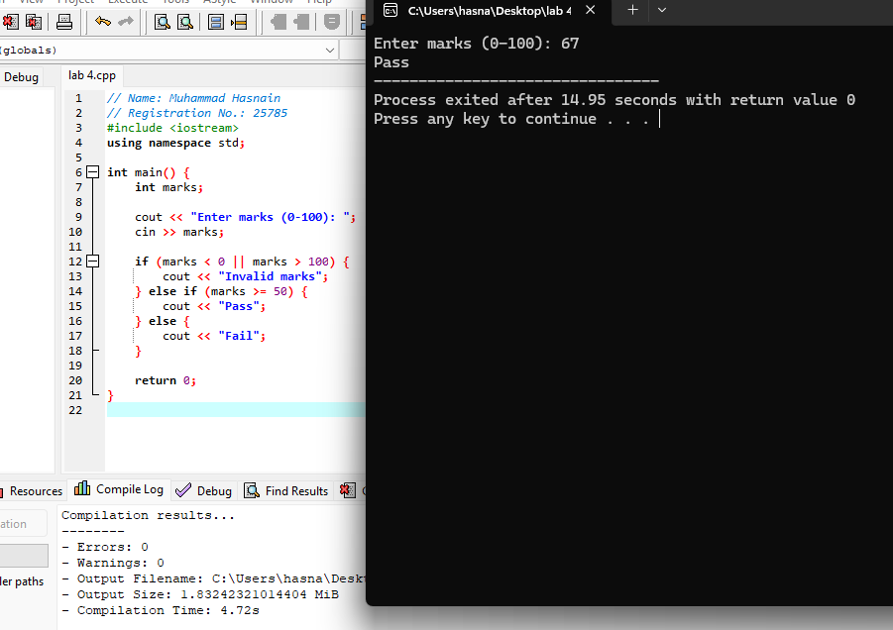

Task 2: Check Even or Odd

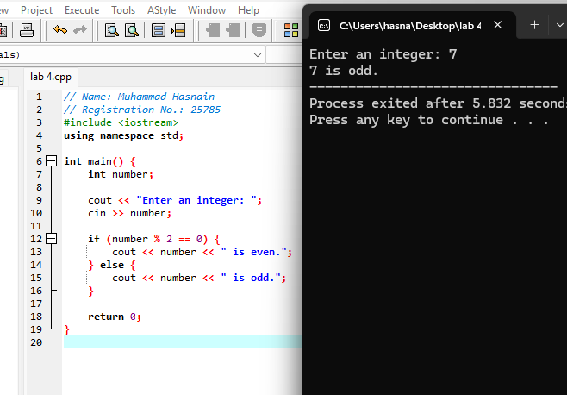

Task 3: Display the Larger Number

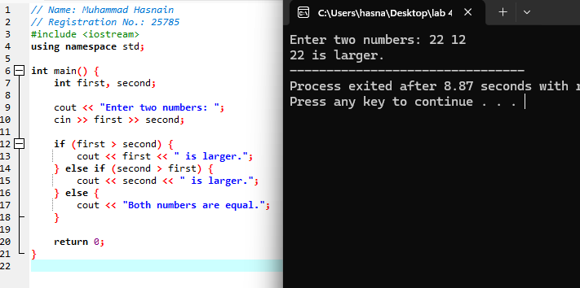

Task 4A: Print Numbers 1 to 20 Using a for Loop

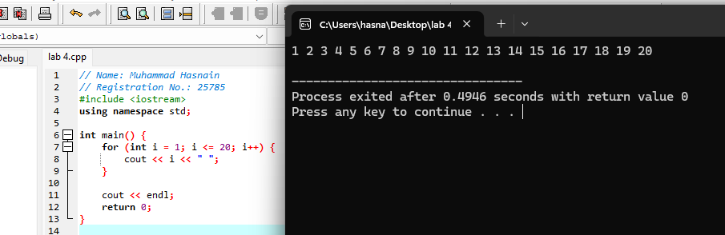

Task 4B: Print Numbers 1 to 20 Using a while Loop

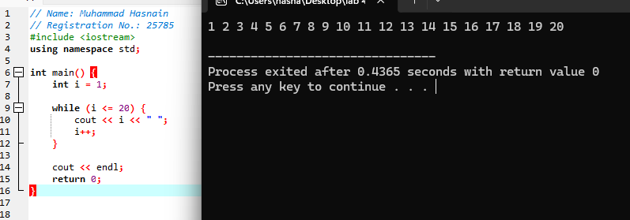

Task 5: Print a Star Pattern
